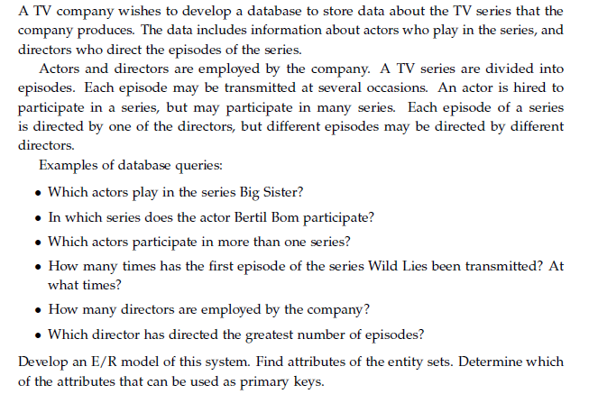

Develop Logical Model and Engineer to Relational Model and Generate DDL